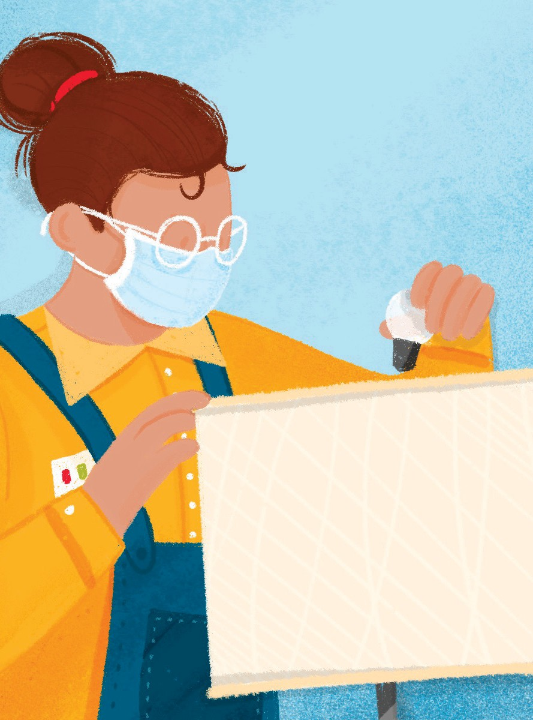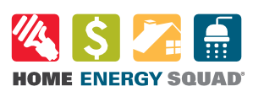

Home Energy Squad provides customized energy solutions for your home.

Your first step is our virtual visit\*. This free visit will help you discover low-cost energy-saving opportunities. If your home could benefit from an in-home visit, we’ll connect you to the best visit for your needs.

We offer two types of in-home visits:

Energy Saver Visit

Intended for newer houses (built from 2000 on), mobile homes, condos, and renters.

Energy Planner Visit

Recommended for homes built before 2000.

Based on what your home needs, visits include the installation of energy-saving materials such as LED lightbulbs, door and attic hatch weather stripping, programmable thermostat, and high-efficiency water fixtures.

After your visit you will be connected to an energy advisor who can help you with next steps by connecting you with qualified contractors and utility rebates.

Free visits available to income-qualified households.

To learn more and to schedule your visit call 651-328-6220 or visit mncee.org/hes.

\*Phone consultation available if preferred.

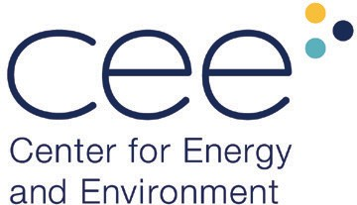The City of Minneapolis is supporting Home Energy Squad by buying down the cost. Home Energy Squad is provided by CenterPoint Energy and Xcel Energy and delivered by the Center for Energy and Environment (CEE), a local nonprofit.